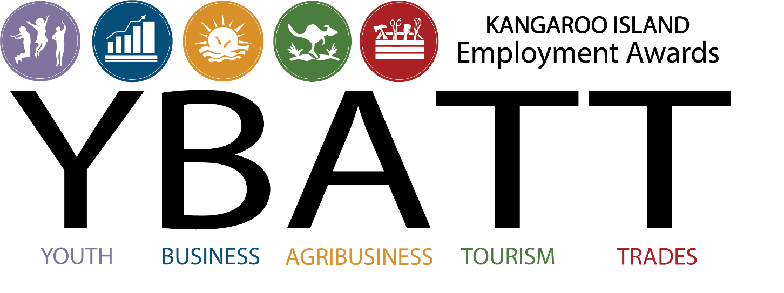

Nomination Kit | Primary Producers

Our Naming Partner

Award Partners
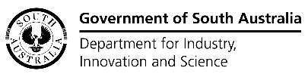
Award Co-Partners
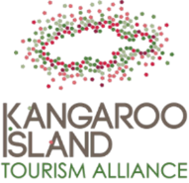
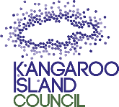
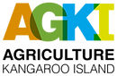
Media Partner Event Partners
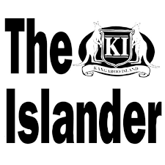 |  | There are still opportunities to become an event partner!
Entertainment Partners

Contents
Information 4
Award Objectives 4
2021/22 Awards 4
Judging 6
Eligibility 6
The Awards Event 6
Criteria 7
Applications 7
The Process 8
Further Information 8
Proponent 8
Application form | AgKI/PIRSA Agtech Hub Best Practice Primary Industry 9
Certification 13
Publicity 14

Information
The inaugural Yumbah Aquaculture Kangaroo Island Employment Awards were held in 2018. Our humble beginnings included one category - the Yumbah Aquaculture Kangaroo Island YOUTH Employee of the Year. The winner (Illija Porter-Baines of KI Ocean Safaris) was announced at the Kangaroo Island Motorcycle Variety Bash event at the Kingscote Town Hall. This event created interest in holding annual awards, however, business and life disrupters came along in 2019 and 2020 which saw a delay in proceedings.
The event’s proponent is ATEC (Adelaide Training and Employment Centre) – a service provider to businesses and employees with local representation. With the support of our new Program Partner, the Kangaroo Island Business Hub, the awards were held again in 2021 to recognise and celebrate the achievements of KI businesses and employees during the calendar year 2020. This saw the expansion of the categories to eight (8) awards and the creation of a standalone event at the Business Hub in early June 2021.
That brings us to the Yumbah Aquaculture Kangaroo Island Employment Awards 2021/22 (YBATT). The success of last year’s awards has seen the Awards Program team revamp the whole program – engaging the very talented Sarah Strong-Law to create our new logo, to help us capture the intent of the awards, being inclusive of, all industry sectors across the Island.
This year we are very pleased to announce that there are eleven (11) awards and prizes up for grabs.
We are planning a big celebration (more details to come) with a 3-course meal prepared by Michelle from Bites at the Bay, live music, and entertainment. This will be an amazing celebration for ALL of the businesses on Kangaroo Island, as well as our nominees and award winners.

Award Objectives
Successful businesses and employees are integral to our society and our economy. Businesses that have highly skilled, confident, and loyal employees (regardless of their role) are more likely to achieve long term success. Successful business leads to ongoing employment and positive gains for the island community and economy. The Yumbah Aquaculture Kangaroo Island Employment Awards celebrate and support the journeys and careers of employees and employers of Kangaroo Island.
The overall aims and objectives of holding these awards are to acknowledge and showcase:
- those Kangaroo Island businesses that:
  - value training and upskilling their employees and are committed to their own professional development,
  - demonstrate innovation and leadership, and
  - contribute to the social and economic outcomes for Kangaroo Island
- those employees, through hard work and dedication, help shine the light on Kangaroo Island businesses.

2021/22 Awards
We are pleased to announce the following exciting award categories, with thanks to our Award Partners for their generous donations:
Apprentice/Trainee  of the Year  ATEC  $1000 cash |  | Sustainable Agriculture Apprentice/Trainee of  the Year  KI Landscape Board  $1000 cash

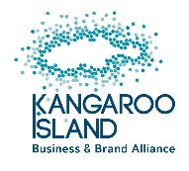 |  | 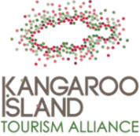
Kangaroo Island Brand Values Business of the Year  KI Business & Brand Alliance  $1000 cash | Best Practice in Primary Production  AgKI / Primary Industries  and Regions SA  $1000 cash | Exceptional Customer  Service Award  KI Tourism Alliance /  Wendy Campana Consultant  $1000 cash

Family Friendly  Business of the Year  Junction Kangaroo Island Community Centre  Vouchers of total value of $1000  (to be issued to families to  spend in your establishment.) | Business Leadership  & Innovation  Department for Industry, Innovation & Science /  KI Business Hub  $1000 cash | Environmentally Sustainable Business of the Year  Kangaroo Island Council / Fleurieu Regional Waste Authority  $1000 cash

Employee of the Year (25+)  NBN Co  $1000 cash | Youth Employee of the Year (15-24)  Local Jobs Program / Aurora Ozone Hotel  $1000 cash | Young Entrepreneur  of the Year  Business SA / Sealink  Business SA $500 + Travel voucher (Value $500)
Please note that prizes may be changed or modified at the discretion of the proponent of the awards, without notice

Judging
A judging panel of carefully selected professionals with combined experience in training, employment, industry sector, leadership will be allocated the very important task of deciding our winners. Where categories are more industry specific a relevant expert will be invited to take part in judging
The judges’ decisions will be final. There are no avenues for reconsideration of the judge’s determination of awards. The identity of all judges remains anonymous.

Eligibility
To be eligible for the award, applicants must be:
- Relevant to the award nominating for an employee of a business operating on Kangaroo Island or an employer/business operating on Kangaroo Island.
- Employees need to be a resident of Kangaroo Island. If the employee now resides off-island, they originally needed to reside on Kangaroo Island in the 12-month period relating to these awards (ie, 2021/22).
- For the purpose of the Youth Employee of the Year (15-24) Award, “Youth” is defined as a person between the ages of 15 and 24.
- Formally registered and recognised as an apprentice / trainee by the relevant government agency (awards relating to Apprenticeships/Traineeships, only).
- Working on Kangaroo Island (may be part-time, full-time or casual, including holiday employment).
- Employer will be judged under the “business” definition detailed at “Characteristics of a Business”, per ATO website (https://www.ato.gov.au/business/starting-your-own-business/before-you-get-started/are-you-in-business-/)
- Employer Award Partners and their employees are eligible to apply, due to the independence of the judging panel - where any conflicts-of-interest are declared, the judge will remove themselves from that evaluation.

The Awards Event
The awards will be presented to the winners at a special event scheduled for Friday 7 October 2022.
The Awards committee is organising an extravaganza to adequately celebrate the achievements of all Kangaroo Island businesses and workforce – whether they are a valued partner of the awards, a nominee, a winner, or simply attending to support Kangaroo Island industries.
More details to come!

Criteria
To be successful in gaining an award, the application must respond to the following criteria, providing details and examples.
Criteria 1: Business Planning
- A good farm business plan is your roadmap to start-up, profitability, and growth. Your business plan will be a living document that you can change as your vision and circumstances shift.
Criteria 2: Recruitment and Skills Development
- Can your farming enterprise demonstrate a commitment to development and maintenance of skills for self and employees/contractors?
Criteria 3: Biosecurity
- How seriously does the farming enterprise take this issue?
Criteria 4: Animal Health
- Animal health and wellbeing is fundamental to the success and sustainability of every farm – can you demonstrate accountability your animals’ welfare.
Criteria 5: Sustainable Production
- Includes management of vegetation, pasture, carbon, drought resilience and biodiversity.

Applications
- Applications will close STRICTLY at 12 noon, Friday, 9 September 2022.
- No extensions will be considered or granted.
- Applications should be:
  - Emailed to Maria Waters, mariaw@atec.asn.au
Or
  - Dropped off in person - marked CONFIDENTIAL – at the Kangaroo Island Business Hub, Commercial Street, Kingscote (next door to Drakes).
Applications must be received before the closing time and date stipulated above.

The Process
Applications Open | Monday, 1 August 2022
Applications Close | Friday, 9 September 2022 (12 Noon)
Judging Period | Monday 12 September 2022 –  Friday 23 September 2022
Award Ceremony | Friday 7 October 2022  6:00 pm till late  Venue TBA

Further Information
For further information, please contact:
 | Maria Waters  Workforce Coordinator – KI  ATEC  Phone: 0401 917 647  Email: mariaw@atec.asn.au | Susi Whitehead  Business Hub Coordinator  KI Business Hub  Phone: 0429 005 356  Email: KIBusinessHub@sa.gov.au

Proponent
The proponent of the Yumbah Aquaculture Kangaroo Island Employment Awards 2021/22 is ATEC (Adelaide Training and Employment Centre), who has invested resources in delivering employer and employee services on Kangaroo Island.

Application form | AgKI/PIRSA Agtech Hub Best Practice Primary Industry

FARM INDUSTRY DETAILS
Business Name
Contact
Phone Number
E-mail Address
Details of any current training being delivered by business

(identify here if an apprenticeship or traineeship is being undertaken or just completed)

Criteria 1: Business Planning
Successful farm management integrates financial and production information in order to evaluate costs, risks, expenses and revenues based on appropriate units of production.
- Do you have a current, up to date Business Plan for your farming enterprise?
- Are your processes and procedures documented?
- Do you have a solid financial plan in place? Do you seek help from a professional financial planner if needed?
- Is your insurance up to date? (eg Public Liability, Workers Compensation and Professional Indemnity.)

Criteria 2: Recruitment and skills development
- Do you have a process to recruit, retain, and motivate employees/contractors?
- Describe how you develop and maintain skills and knowledge – your own and/or those of your employees/contractors.
- Are you Work Health Safety Policy and Procedures up to date, and are they printed and readily available to provide to anyone entering your property? Is this included in your induction of new employees/contractors?
- Do you look after your mental health and wellbeing and that of your employees/contractors? Please describe.

Criteria 3: Biosecurity
- Do you have adequate fencing? Describe how it contributes to your business enterprise’s biosecurity.
- Do you have a documented quarantined procedure that you follow?
- What due diligence do you do on livestock, seed, and fodder purchases?
- What are the key biosecurity threats to your business enterprise and what are your strategies to deal with them?
- What would you do if you suspected a biosecurity issue on:
  - On your property
  - On a neighbouring property

Criteria 4: Animal health
If you are crop farming only, please skip these questions.
- The Australian Standards provide the basis for developing and implementing consistent legislation and enforcement across Australia. Are you familiar with the relevant standards relating to your farming enterprise?
- Provide an example of how you meet one or two of these standards.

Criteria 5: Sustainable Production
Provide an example for any or each of the following (where relevant to your property).
- Managing Grazing and Cropping systems – How do you manage the capacity and limitations of your land types, and what management practices have been introduced or improved.
- Managing soil health – what is your approach to maintain or improving soil health. What practices have you introduced (or ceased) to improve or maintain soil health. What production improvements have you seen from these changes.
- Build drought resilience - demonstrate an understanding the capacity and limitations of your land types, promote drought planning and management practices that are critical for the health and sustainability of you and your farming enterprise.
- Managing biodiversity – How have you improved the health and connectivity of native vegetation and health of waterways on your property? Or provided support for KI’s threatened or Iconic species.

Final Comments
Please provide any additional information you would like to support your nomination.

Certification
I certify that the information included in this application is to the best of my knowledge true in all aspects, and that I have faithfully represented the employer.
Name
Signature
Date

Publicity
Image and bio
Please attach a high-quality image of the business/person being nominated for the award. Below, please add a few words that would be suitable to include in a social media post (25 words or less).
Radio Interview
Would the nominee like to be interviewed by 5kixFM Community Radio? |  | Yes | No
If yes, please provide best contact details:
Acknowledgement
The below signed business or employee approves the use of their image and the brief profile on social media.
Name
Signature
Date
Please forward your completed application form to:
Maria Waters
Workforce Coordinator – KI
ATEC
E-mail: mariaw@atec.asn.au
or
Drop In: Kangaroo Island Business Hub, Commercial St,
Kingscote SA 5223, marked “CONFIDENTIAL”

